Overview of service
Whenever you create a pod, the containers will have Private IP addresses.
Issue1:-
Let’s assume we have 2 services one is Frontend and another one is Backend. The Fronted is having 10.244.0.5 and backend is having 10.244.0.6. Now Frontend wants to communicate with backend we need to specify backend’s IP 10.244.0.6 in Frontend.So the service will start communicate. But If backend service gets down the deployment will create a new server which is with 10.244.0.10 since it’s IP address is hard coded the frontend was unable to communicate with backend the frontend application will be down.
Issue2:-
Let’s assume we have one frontend server and three backend servers in future we will scale it to ten. In this case how we will configure those IPs in Frontend?
To overcome above issues in K8s we will use ‘Services’. The Services is having ‘backend-gateway’ the backend gateway will be having set of pods the frontend is to send the request to backend-gateway. So If any pod is down it will stop the communication with that pod and it will send the communication to remaining pods.
Here backend-gateway acts an intermittent so this is called as a service.
Overview of K8s service:-
- K8s Service can act as an abstraction which can provide a single IP address and DNS through which pods can be accessed.
- This layer of abstraction allows us to perform lot of operations like load balancing, scaling of pods and others
Types of K8s services
- NodePort
- ClusterIP
- LoadBalancer
- ExternalName
Creating First Service and Endpoint
Service is a gateway that distributes the incoming traffic between its endpoints
Endpoints are the underlying PODS to which the traffic will be routed to.
Endpoints=underlying pods
Step1:-
Creating 2 Backend pods by running the below commands
kubectl run backend-pod-1 –image=nginx
kubectl run backend-pod-2 –image=nginx

Step2-Creating Frontend PODS
Kubectl run frontend-pod –image=ubuntu – sleep 3600
Now we are going to check the connection between frontend to backend.
Kubectl exec -it frontend-pod – bash
After jumping into the pod install the curl by running
Apt-get update && apt-get install curl -y
After that run ‘curl <IP address of the backend pod>’
You can see it’s communicate with backend pod
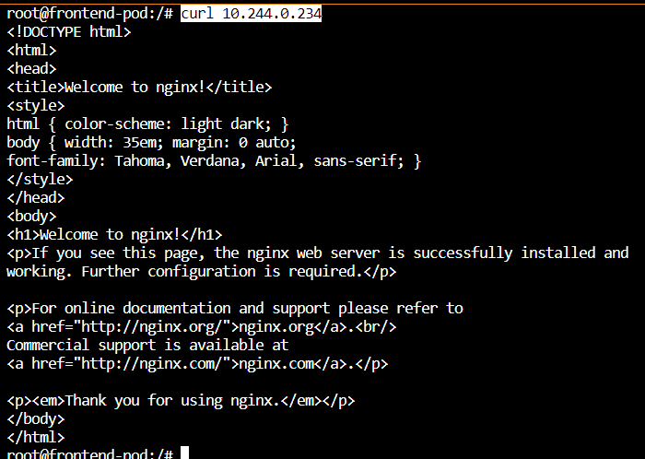
Step3- Create a new service
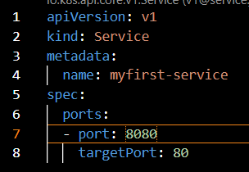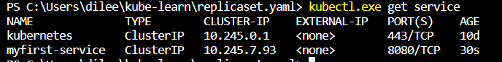
Now we have created a service but it’s not having any endpoints
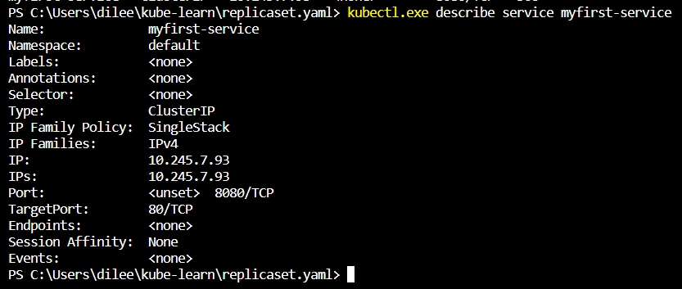
Now if jump into the Frontend pod and do the curl command with the IP address of the server followed by port. It won’t show anything.
curl 10.245.265.81:8080
Now we need to create the endpoint
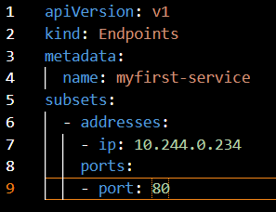
In above script we will mention the same name myfirst-service which we mentioned in the service.yaml and the ip address will backend ip.
Now if you run kubectl describe you can see the backend pod ip
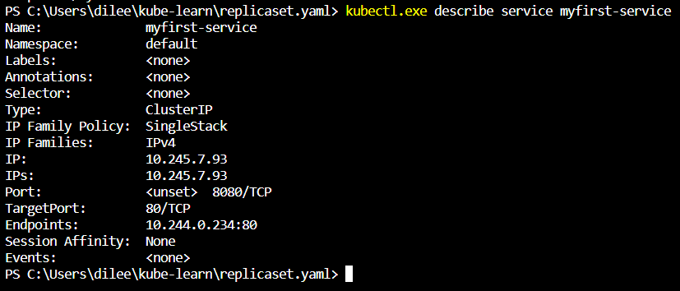
Now If you run the curl command from frontend app with curl <service ip address>:8080 it will communicate to the backend pod.
Service Type:ClusterIP
Whenever service type is ClusterIP, an internal cluster IP address is assigned to the service. This is a default Service Type.
Since an internal cluster IP is assigned, it can only be reachable from within the cluster. In previous session we have seen the cluster IP.It can only reachable with inside of the cluster service we caan’t reach with internet.
Using selectors for Service Endpoints
Challenges with Manual Appraoch of Endpoints:-
At this stage, we were manually defining the IP address of the PODS in Endpoints.
If there are 500 PODS, we will have to manually define each IP in endpoint
Integrations of Service with Selectors:-
K8s allows us to define the list of labels of PODS that needs to be added as part of Endpoints.
All PODS that matches that label will be added.
Step 1-Creating deployments
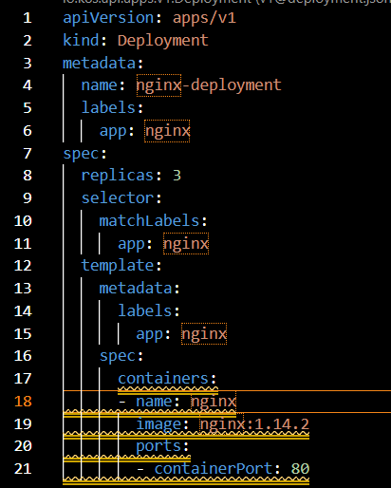
Now we will write script for selector in service.
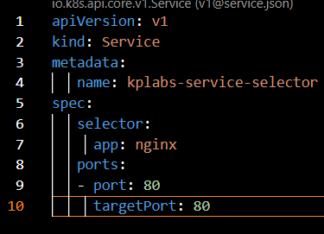
Now we will verify the created endpoints with describe command
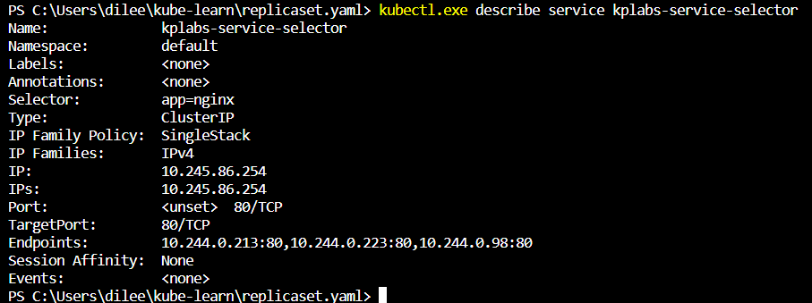
You can see 3 endpoints IP.
Now sudden sales come in your site. Now you need to increase in that case also the endpoints will be automatically added.
Now if you reverify the with describe command for the end points you can see all 10 IPs are added to endpoints
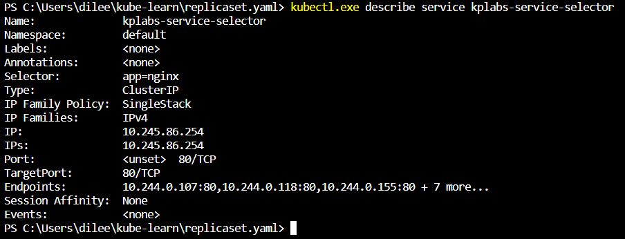
Here it’s showing ‘7 more’ If you want to see exact list.
To list endpoints run below command
kubectl get endpoints
and then to verify each endpoint in deatil run below command
kubectl describe endpoints <endpoint name>
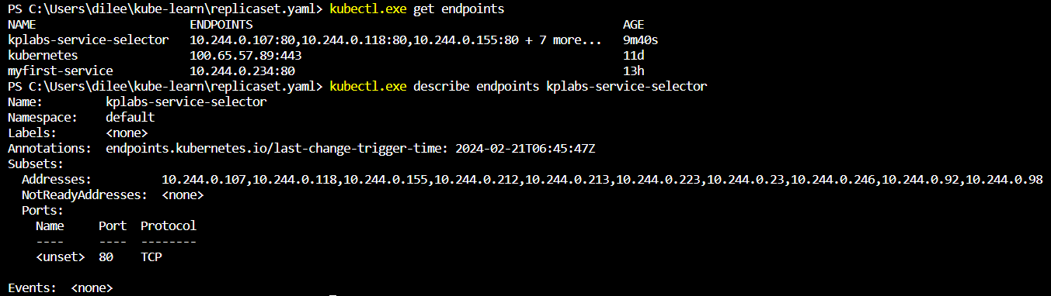
Now If you add a pod manually with a command with the label app=nginx, the selector will pick up that pod as well by checking the label match and it will also be added to the endpoints list.Now total 11 pods.
Service Type:NodePort
Understanding NodePort:-
NodePort exposes the Service on each Node’s IP at a static port (NodePort).
You will be able to contact the NodePort Service, from outside the cluster, by requesting <WorkerIP>:<NodePort>.
If servicetype is NodePort, then K8s will allocate a port (default: 30000-32767) on every worker node.
Eg:-
As of now we have seen clusterIP, which it will not allow the customer from internet. With the help of NodePort the customer will access the service, first the communication will go to nodeIP along with node port and then it will reach to the service.
Handson:-
Now we are going create a pod with a label
kubectl run nodeport-pod --labels="type=publicpod" --image=nginx
Now we will create a NodePort service
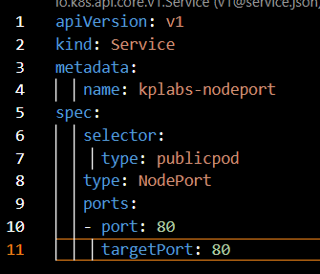
Now if you run kubectl get service. You can see the type=NodePort
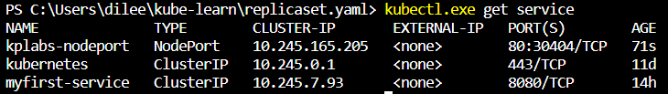
Now, If we want to connect to the NodePort service we need to use ip addr of the node followed by NodePort.
For that collect the extrenal IP by running
kubectl get nodes -o wide
and for the NodePort kubectl get service
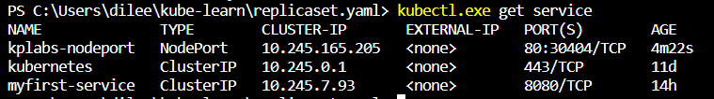
If you search with 139.59.69.50:30404 you can see nginx page
Service Type:Load Balancer
Challenge in NodePort: We need to access it via IP/DNS:Port. It will be hard the customer needs to remember.
Understanding LoadBalancer Service Type:-
- LoadBalancer Service Type will automatically deploy an external load balancer.
- This load balancer takes care of routing requests to the underlying service.
Cleint -> LoadBalancer-> NodePort->Service-POD
Step1-Create a pod with the label
kubectl run lb-pod --labels="type=loadbalanced" --image=nginx
Step2-creating a service with the type LoadBalancer
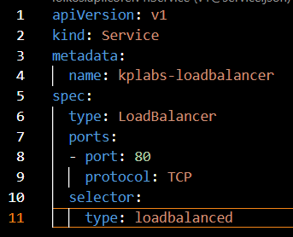
The above script will create a new LB in digital ocean
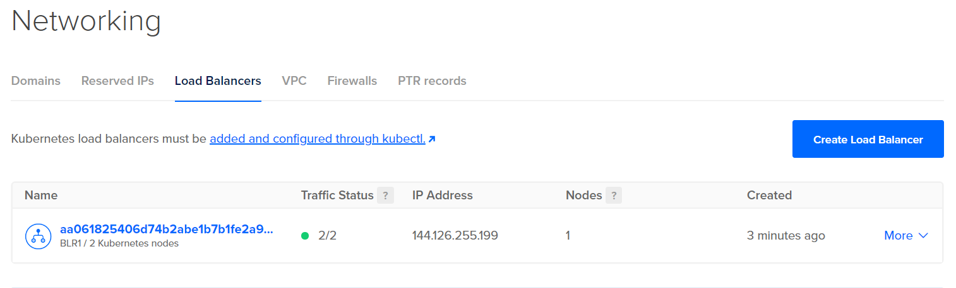
Whatever LB created in Digital ocean it will automatically gets assign/config to the NodePort.
Now if you serach with LB public Ip you can see nginx page. You can see the forwarding rule of LB.
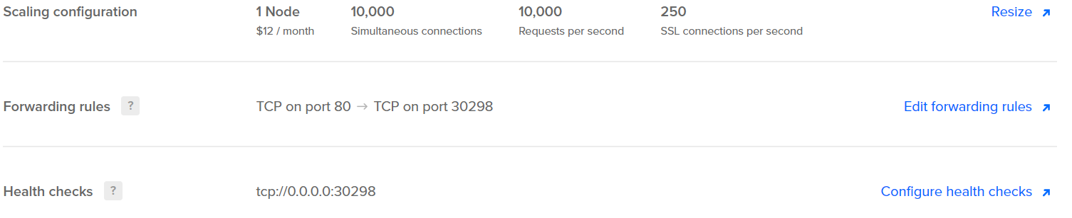
Note:-
- The overall implementation of LoadBalancer depends on your Cloud Provider.
- If you plan to use it in bare-metal, then you will have to provide own load balancer implementation.
**Pls clean up the load balancer
Generating Service Manifest via CLI
To explain this topic, We need to create a POD and a DEPLOYMENT.
For POD:-
kubectl run nginx --image=nginx
For Deployment:-
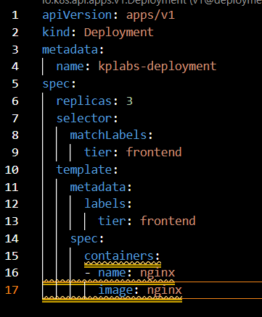
Label is frontend which we need to consider here
Service Manifest- POD:-
This will create a manifest file for service and add POD in its endpoints
kubectl expose pod nginx --name nginx-service --port=80 --target-port=80 --dry-run=client -o yaml
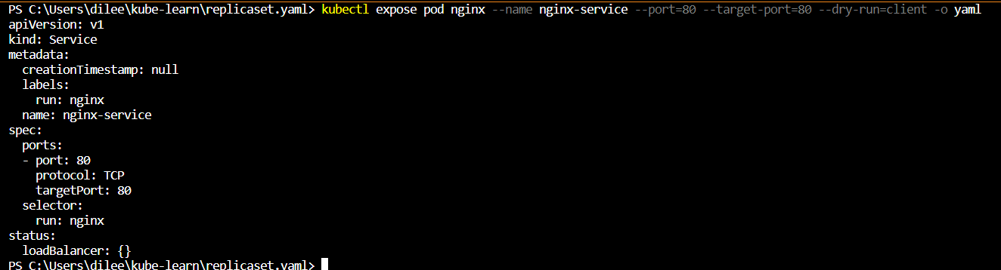
Service Manifest-NodePort:-
Create a service manifest of type NodePort and add POD as part of it’s endpoints.
kubectl expose pod nginx --name nginx-nodeport-service --port=80 --target-port=80 --type=NodePort --dry-run=client -o yaml
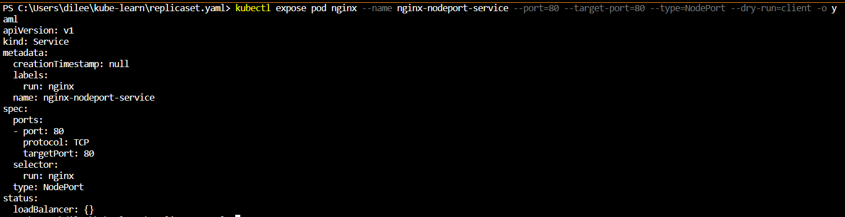
Ignore status: LoadBalancer:{}
Service Manifest-Deployment:-
This will create file for service and add deployment PODS in its endpoints
kubectl expose deployment kplabs-deployment --name nginx-deployment-service --port=80 --target-port=8000 –dry-run=8080 -o yaml

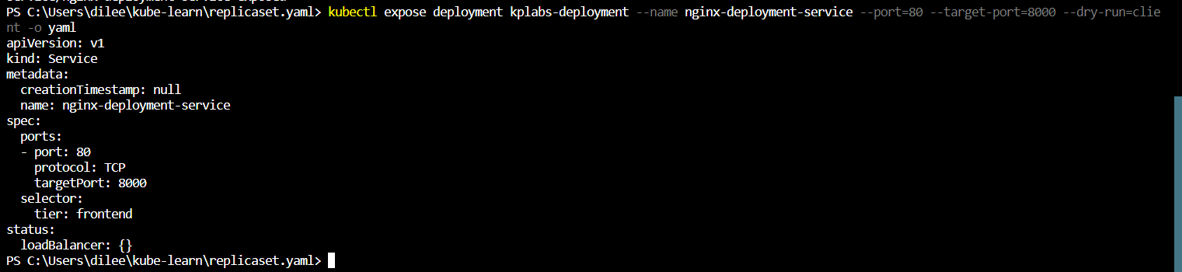
Overview of ingress
Challenge with typical LoadBalancer deployment:-
Whenever making use of LoadBalancer Service Type, out of box, you can make use of single website.
User->LB->Service-> POD
Challenge-Multiple Website Scenario
User-> LB ->example-service (example.com) -> POD
->kplabs-service (kplabs.in) -> POD
But we cannot achieve this with Layer 4 LB. To achieve this we need to use 2 LBs so cost will increase.
To achieve this, we have Intermittent gateway it has intelligence to do the Layer 7 related routing.
Overview of Ingress:-
K8s Ingress is a collection of routing rules which governs how external users access the service running within the K8s cluster.
Ingress can provides various features which includes:
- Load Balancing
- SSL Termination
- Named-based Virtual hosting
Understanding Ingress Resources and Ingress Controllers
There are two sub-components when we discuss about Ingress:
- Ingress Resource/Rules
- Ingress Controllers
Ingress Resource contains set of routing rules based on which traffic is routed to a service.
Ingress Controller takes care of the Layer 7 proxy to implement ingress rules.
You must have an ingress controller to satisfy an Ingress. Only creating an Ingress resource has no effect.
Ingress gateway=Ingress controller
Rule | Host | Service
1 | Example.com | Example-service
2 | Kplabs.in | Kplabs-service

Overview of Helm
Understanding Helm:-
Helm is one of the package manager of K8s.
K8s application can contain lot of objects like Deployments, Secrets, LoadBalancers, Volumes, Services,Ingress and others.
So we will combine all the above objects we called it as Helm chart. We will deploy this chart on the Cluster so it will be having all the required objects.
Repository for Helm Charts:-
One of the advantage for Helm chart is repo. Let’s assume if you want to use wordpress or Jenkins simply go to repo search for wordpress and select the required chart and deploy it on cluster.
Repo:- Artifact Hub
Helm Installation:-
Go to this link Releases · helm/helm (github.com) . Download the windows package copy the .exe file to binaries folder where Kubernetes.exe present.

Deploy WordPress chart:-
helm install <name of the chart> <chartname>
helm install demo-release bitnami/wordpress
The above one didn’t work because we haven’t configured repo, in later session we will config this. I checked in official doc. If found below one.
helm install demo-release oci://registry-1.docker.io/bitnamicharts/wordpress
The above command is working.
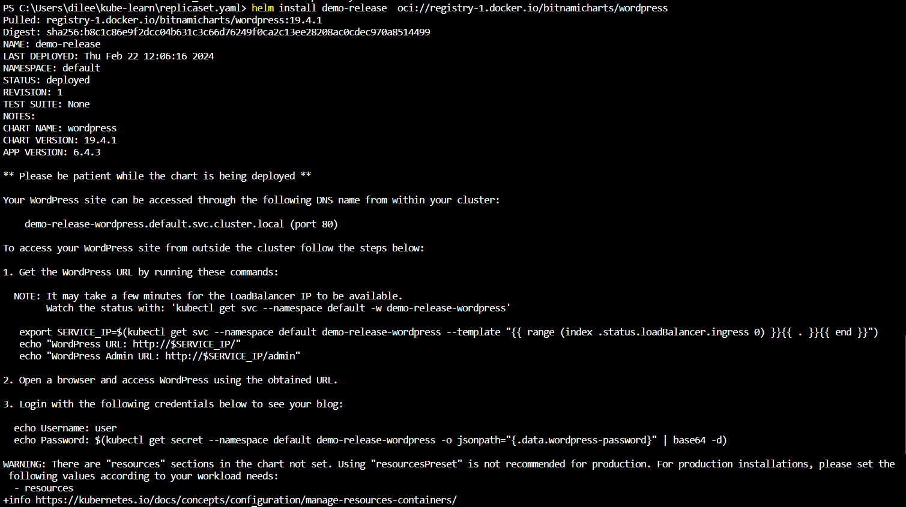
*** Be careful it will create the LB. Delete after the work.
The above command will deploy all the objects associate with it. You can check that in github repo under template folder.
charts/bitnami/wordpress/templates at main · bitnami/charts · GitHub
This you will get by searching bitnami/charts in google
If you want you can collect each template and can create separately or you can do as done in above.
Now, If you search the with LB IP you can see the wordpress blog
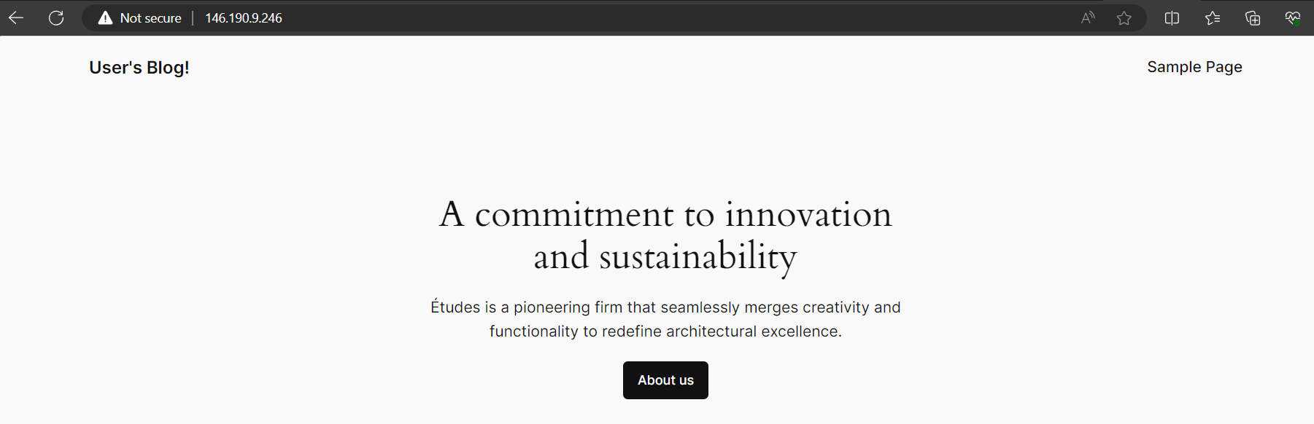
To unistall the Wordpress helm chart
helm uninstall demo-release
A chart is a Helm package. It contains all of the definitions necessary to run an application, tool, or service inside of a K8s cluster.
A Repo is the place where charts can be collected and shared.
Deploying our First Helm Chart
Installing Helm chart:-
To install a new package, use the helm install command
Helm Package Location:-
Helm package can be placed in local disk or can be stored centrally in public or private repository.
Depending on the location of the package, there is a slight change in the installation step.
How to config the repo link:-
For wordpress it’s not showing for Jenkins it’s showing in the doc.
For Jenkins Helm chart:
helm repo add jenkins https://charts.jenkins.io
helm repo update

helm install [RELEASE_NAME] jenkins/jenkins [flags]

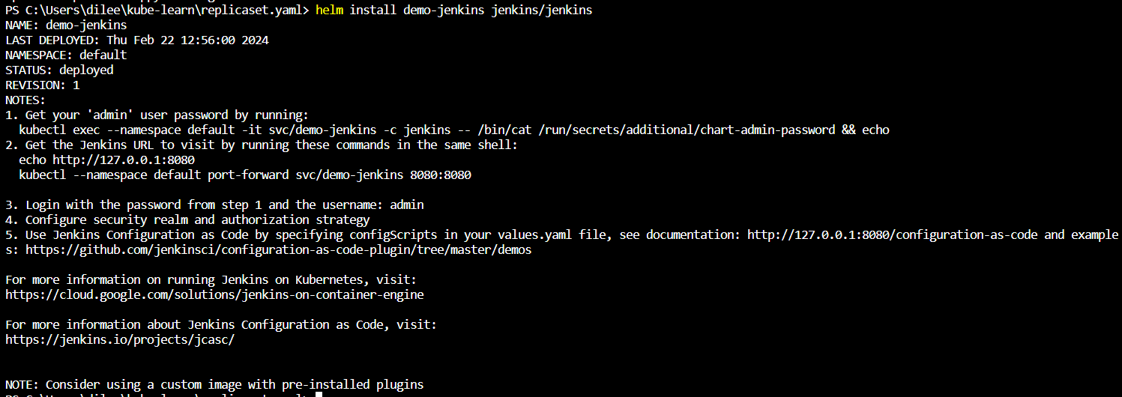
For wordpress it didn’t work we tried with full repo link, For Jenkins since we configure the repo link it’s working.
To list helm chat helm list
Note:- sometimes due to some issue the POD of the Helm won’t get up for that we need to check the log by using describe command and then we need to trouble shoot it.
Basic Helm commands:-
Commands | Description
Helm repo add | Adds a chart repo
Helm install <chart> | Installs Helm package
Helm uninstall <release> | Uninstalls the release
Helm repo list | List repos
Helm list | List the releases

Creating Ingress Resource
Overview of Name Based Virtual Hosting:-
Name-based virtual hosts supports routing HTTP traffic to multiple host names at the same IP address.
Rule | Host | Service
1 | Example.com | Example-service
2 | Kplabs.in | Kplabs-service

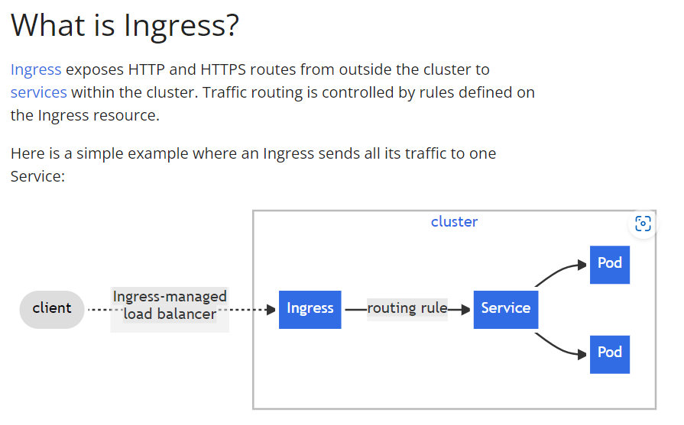
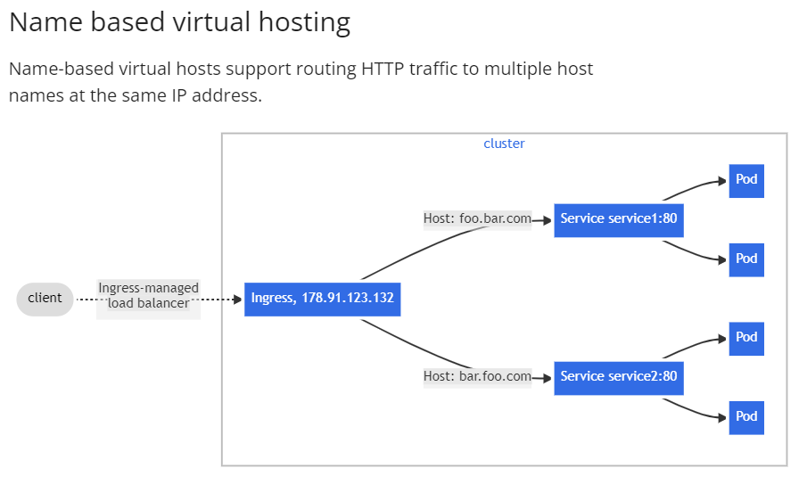
The above pictures took SS from doc. Ingress | Kubernetes
First we need to create pods and then service and then Ingress.
PODS:-
Now we need to assign these PODS to a service
SERVICE:-
Now we need to assign these services to ingress
Before that we need to create frontend POD to check whether service is properly communicating or not.
Now Jump into the POD and install curl & nano
And do curl with both the service’s IP.
Create the ingress
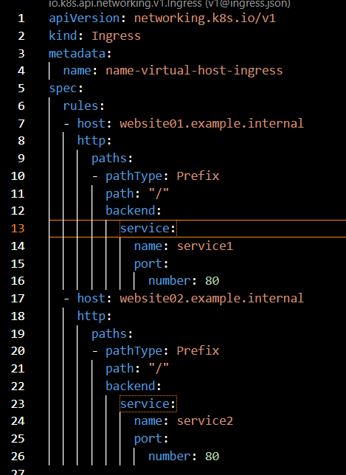
To check kubectl get ingress
Deploying Ingress Controller
For Ingress controller visit this doc Ingress Controllers | Kubernetes
Ingress is currently supporting for AWS, GCE and nginx
Now we are going to create the nginx one. If you click on nginx it will redirect to github page ingress-nginx/README.md at main · kubernetes/ingress-nginx · GitHub .
Now click on Getting Started it will redirect to Ingress controller documentation. Installation Guide - Ingress-Nginx Controller (kubernetes.github.io) . Here we need to look for Quick start’s helm.
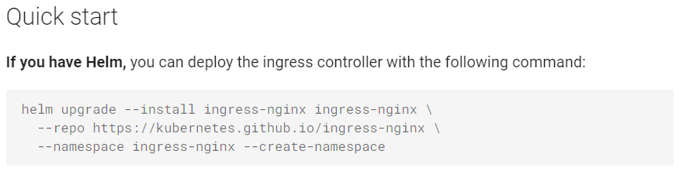
Copy the script and execute it in oneline without ‘\’.
We can verify it by running
helm list - -all-namespaces
If you run kubectl get ingressclass it will list the controller
If do kubectl get service in the namespace ingress-nginx
kubectl get service -n ingress-nginx
It has created a LB.
Now we need to mention the ingress controller name in the ingress script. We need to add ingressClassName in spec.
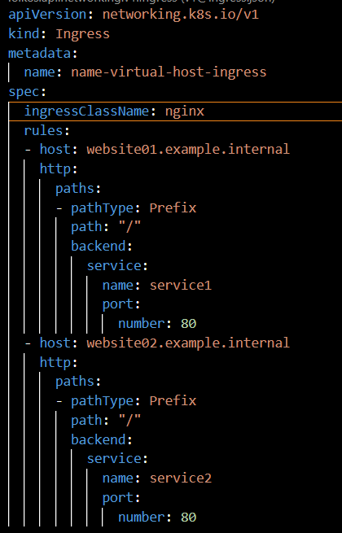
Now you can see the new event in the ingress that is “Schedule for sync”
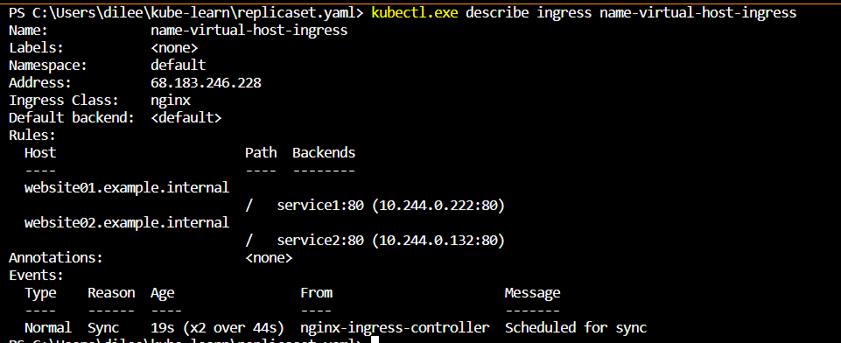
Now we need configure the hosts in frontend website01.example.internal & website02.example.internal in Frontend pod.
After jumping into the pod
Nano /etc/hosts
Add LB IP and the host names like this at last
And save the file. what it will do is usually whenever we do search for website01 or 02 it will go to LB. Since we are in local that’s why we configured in hosts file.
Now If we do curl from Frontend POD with the host name it will reply back. For easy understanding we will give names as site01 and site02 for each POD by editing default page. So when we do curl website01.example.internal it should show site01 same for site01 also.
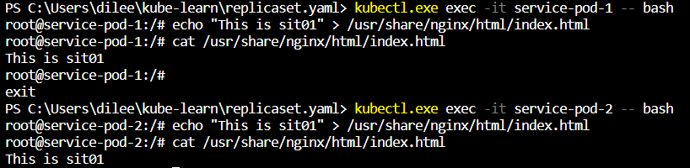
Now jump to Frontend and do curl
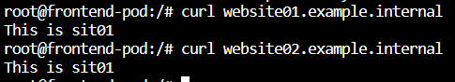
Small typo it should show site02 pls ignore.
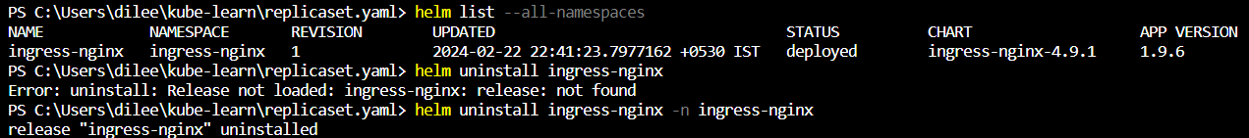
Kubernetes Namespace
Overview of Namespace:-
K8s Supports multiple virtual clusters backed by the same physical cluster. The virtual clusters are called namespaces.
Virtual cluster21
Virtual cluster11

Team B
Team A

We have a physical cluster inside that we have created 2 virtual clusters with the name of Team A and Team B by using namespace.
Eg:- If a person belongs to Team A wants to create/delete a pod he can do that in Virtual cluster1.
Use-Case:-
- You provide all the users within Team A full access on”Pods” resources [only for Team A NS].
- You provide all the users within Team A full access on deployments [only for Team B NS].
To list Namspace kubectl get namespace
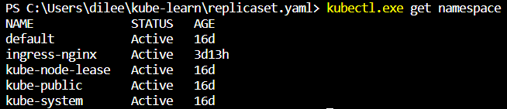
In general if we run kubectl run commands it will create the objects in default namespace.
If you want list the pods which are under the NS.
kubectl get pods –namespace kube-system
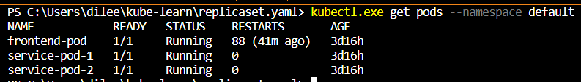
Creation of NS:-
Kubectl create namespace teama
To list “kubectl get namespace”
To run the POD explicitly in the NS “kubectl run nginx –image=nginx –namespace teama”
Namespace | Description
Default | The default namespace for objects with no other namespace
Kube-system | The namespace for objects created by the K8s system
Kube-public | This NS is created automatically and is readable by all users. IT contains info, like CA, that helps kubeadm join and authenticate worker nodes.
Kube-node-release | The kube-node-release namespace contains lease objects that are used by kubelet to determine node health

Overview of Service Accounts
K8s Clusters have two categories of accounts:
- User Accounts (For humans)
- Service Accounts (For Applications)
To connect to K8s cluster, an entity needs to have some kind of authentication credentials.
If we run any command let’s assume “kubectl get pods” it will display the output this happening due to authentication.
You can see it in “config” file in This PC>Local Disk(C:)>Users>dilee>.kube
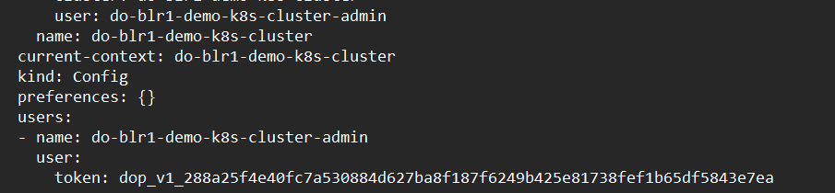
You can see user and token.
Another way to authenticate is certificate.
Different type of credentials:-
- Humans will use User Accounts to connect to Cluster.
- Pods/Applications will use Service Accounts to connect to Cluster.
Service Accounts in K8s Cluster:-
Various different components of K8s uses service accounts to communicate with the cluster.
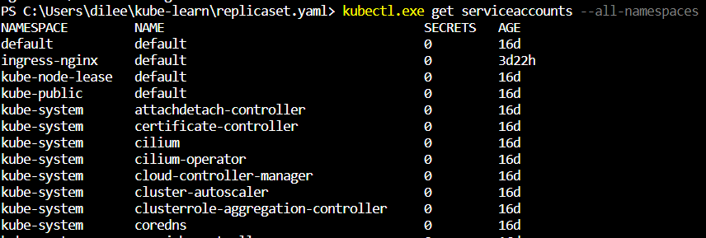
You can see lot of services using for the operations through machine entities.
Eg:-
Let’s assume that a service Account is associated with Pod A.
Pod A can use the token associated with the service account to perform some actions on K8s cluster.
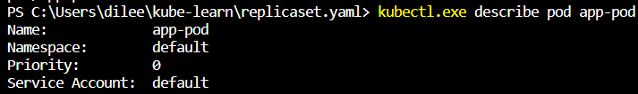
If we create a pod it took default Service account from above image you can see that.
To check this, we will connect to the cluster from pod by using token.For that we will jump into the POD and we will do cd command to /var/run/secrets/kubernetes.io/serviceaccount/
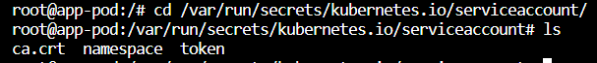
If you cat the token file
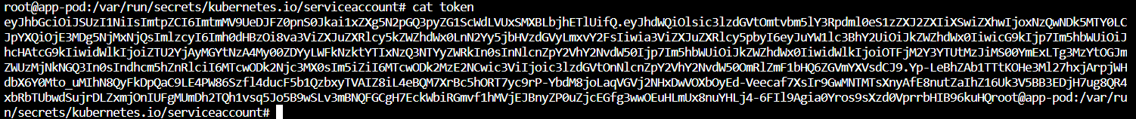
If any app running inside the POD can connect to this specific directory and fetch the token the app can authenticate to cluster and perform some operations it depends upon the permission of the token.
First we will call the token as a variable
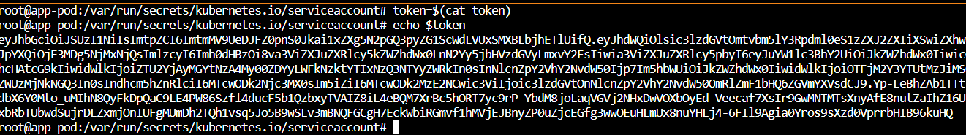
Now we need to see the cluster info for control plane.
Collect the control plane url. Run the curl command from POD.
curl -k -H "Authorization: Bearer $token" https://01d364ab-c23b-49a1-b7ed-f6be179c630b.k8s.ondigitalocean.com/api/v1
You will get a big list about the cluster
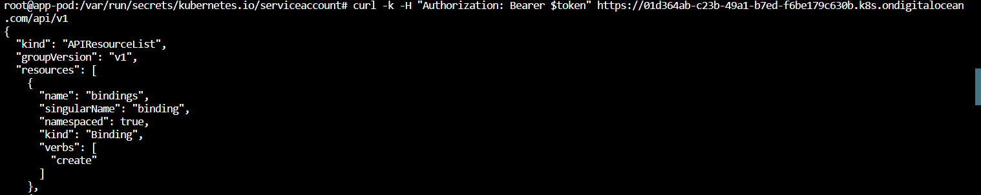
We are seeing is that our POD is successfully able to connect to K8s cluster.

Service Accounts-Points to Note
Default Service Account:-
When you create a cluster, K8s automatically creates a ServiceAccount object named default for every namespace in your cluster.
To list “kubectl get serviceaccount”
To check for a NS “kubectl get sa -n kube-system” here also you can see a default sa.
Service Account and Permissions:-
Each Service Account in K8s can be associated with certain permissions.
When POD uses the service account, it can inherit the permissions.
Permissions
Read Access to logs
Full Access to Pods

Point to Note:-
The default sa in each NS get no permissions by default other than the default API discovery permissions that K8s grants to all authenticated principals if role-based access control (RBAC) is enabled.
Assigning Pods to Service Accounts:-
If you deploy POD in a NS, and you don’t manually assign a sa to the Pod, K8s assigns the default sa for that NS to the POD.
To see the token path for a POD “kubectl describe pod <pod name> -n <NameSPace name>
You can see the token path under “Containers” in “mount”.
Service Accounts- Practical Scenarios
Creating Service Accounts:-
You can create a new service account directly using kubectl
“kubectl create serviceaccount custom-token”
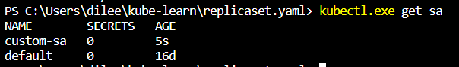
Mounting Custom Service Accounts to Pod:-
You can use serviceAccountName to specify custom service account token as part of the POD.
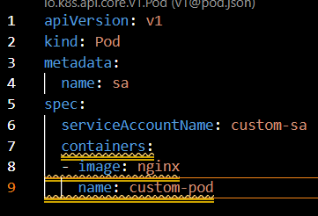
You can see service account as custom-sa
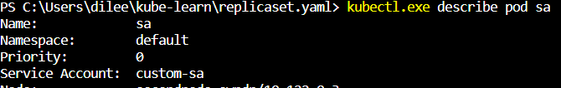
Named Port
We can also associate a name associated with the port. This name must be unique within the pod.
Named Port Reference in Service File:-
Instead of Port Number, we can also specify the name while creating service.
Run “kubectl.exe expose pod nginx --name first-svc --port=80 --target-port=http --type=NodePort”
Run “Kubectl get svc first-svc -o yaml”

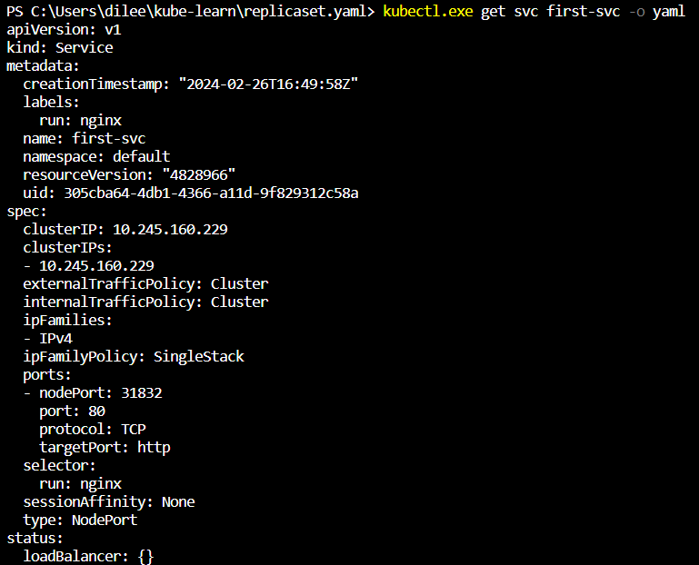
You can see protocol is TCP and targetport is http
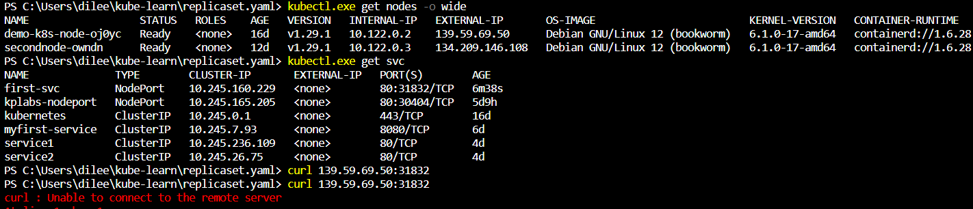
If we curl <node IP>: <service port>. It will show connection failed.
After running “kubectl.exe run nginx2 --image=nginx --port=80 --dry-run=client -o yaml > pod_named.yaml” go to the pod_name.yaml change the “name” under the “ports” to “custom-http”.
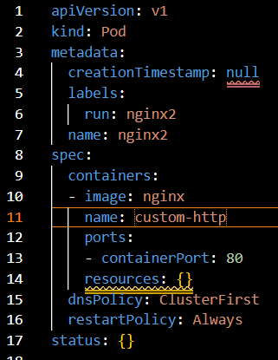
Run “kubectl.exe expose pod nginx2 --name named-svc --port=80 --target-port=custom-http --type=NodePort”
Now If you run the curl <node IP>: <service port>.It will work.
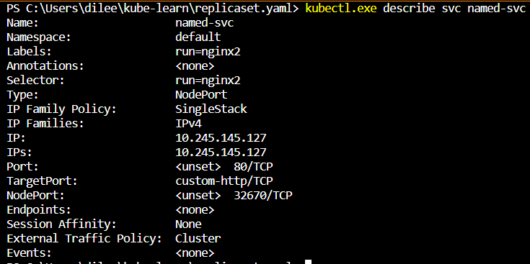
The curl command before and after as expected tutor is executing this in root@kubeadm cli I’m running in windows local.
***Need to check.

